NP on HTML, XHTML, and DHTML: The Hitori Puzzle
Annotated Solutions

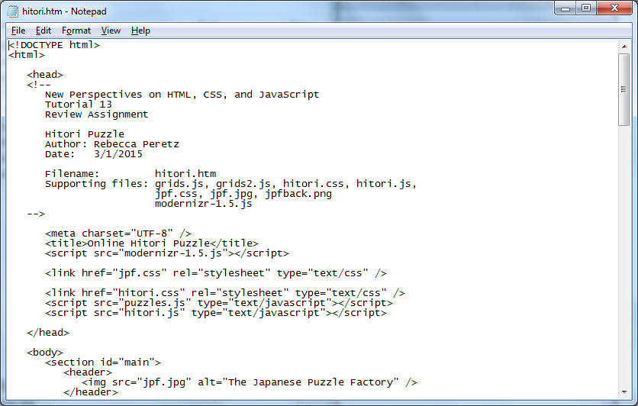
Link to puzzles.js and hitori.js added

Student’s name and date entered

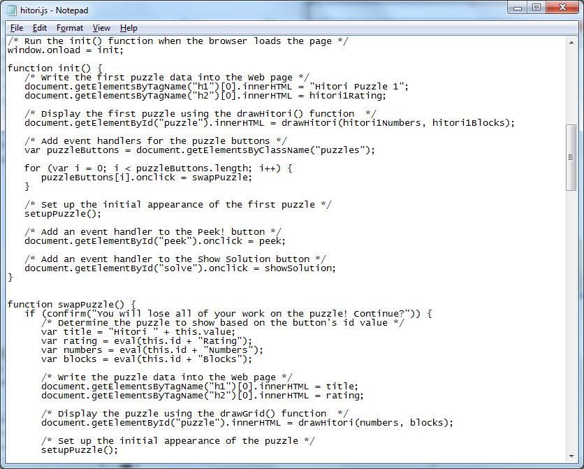
init() function added to hitori.js

swapPuzzle() function created

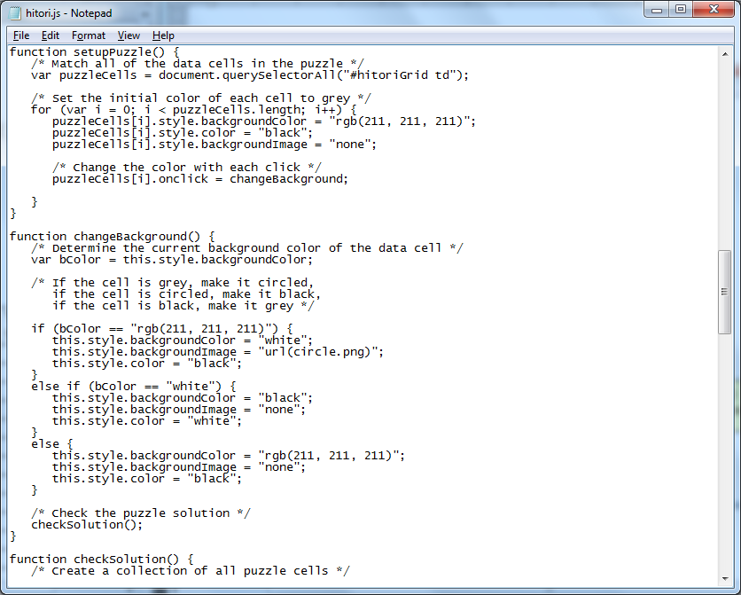
setupPuzzle() function created

changeBackground() function created

checkSolution() function created

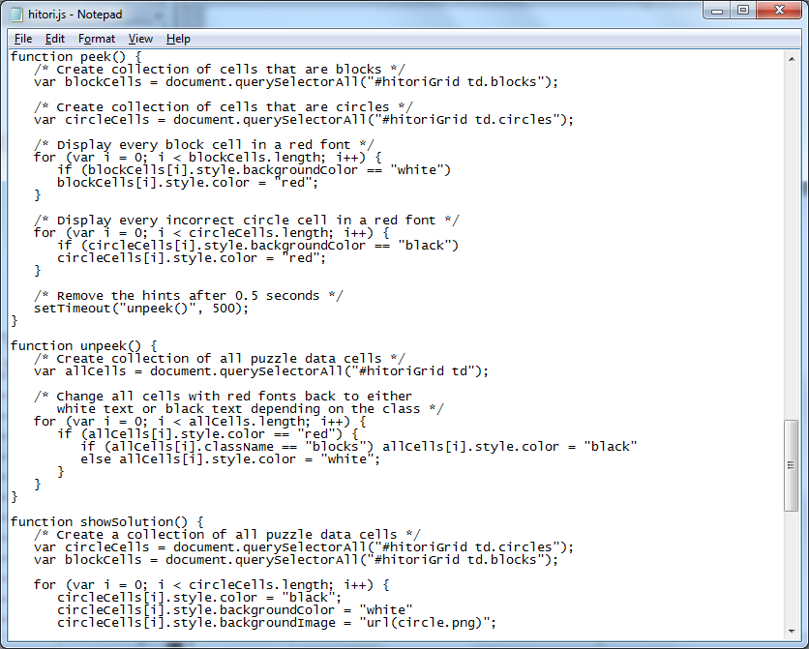
peek() function created

showSolution() function created

unpeek() function created

Comments are added throughout

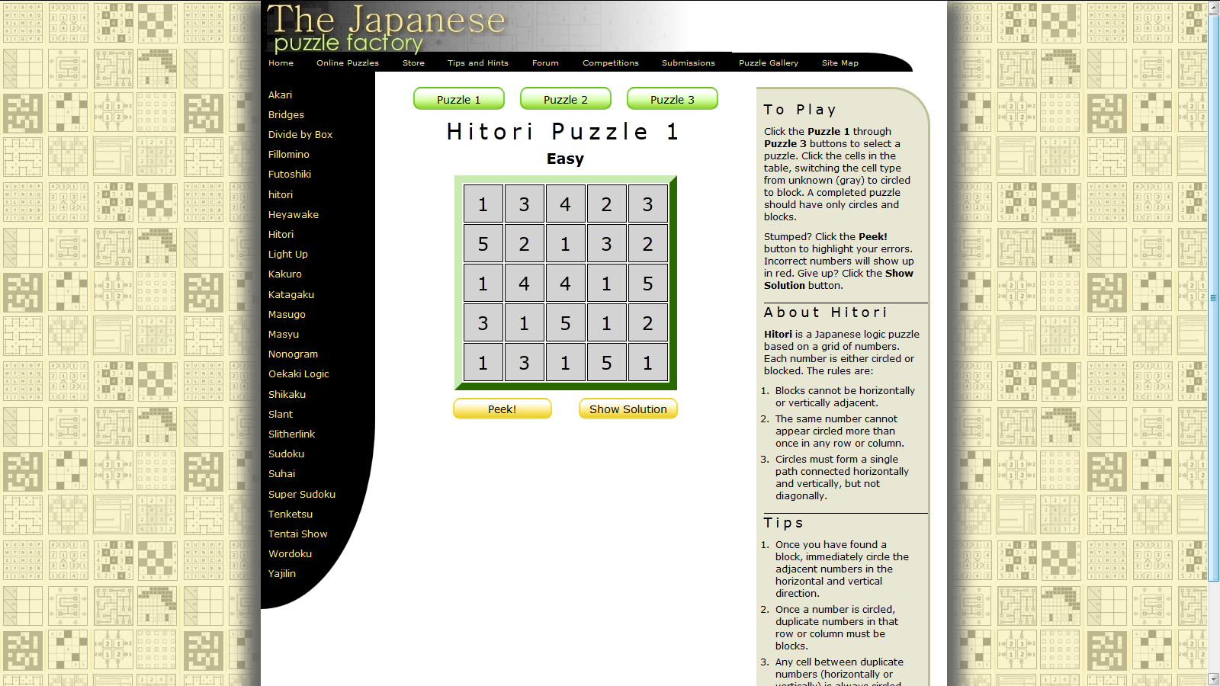
Functions are tested in hitori.htm file

